**Day 55**

**What to do?**

Project #6 Object Detection: You will learn more concepts by doing this project. Or your own ideas.

**Face Mask recognition (without YOLO):**

Architecture: VGG16 with Dense layer of softmax activation function.

Compiler: Adam optimization with learning rate of 0.0001, loss of categorical cross entropy and accuracy is evaluated.

Training: The model is then fit with 10 epochs (which is too much, as the model works well with even 5 epochs).

**Results:**

* Training loss: 0.0172; Validation loss: 0.0271 (by 10th epoch)
* Training accuracy: 99.62%; Validation accuracy: 99.16% (by 10th epoch)

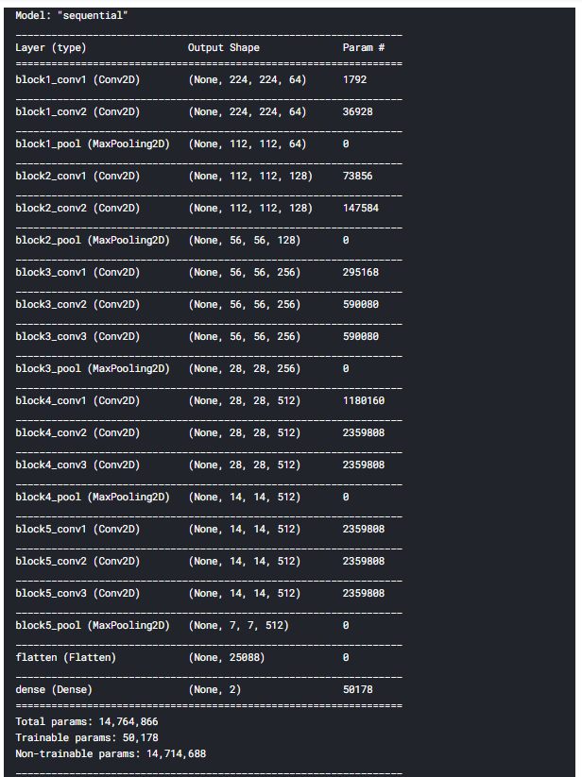

Fig 1. Model Summary

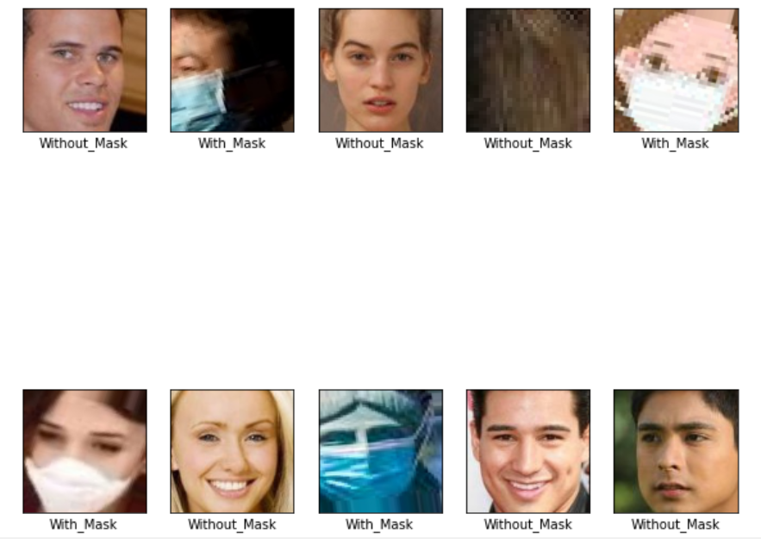

Fig 2. Testing set results